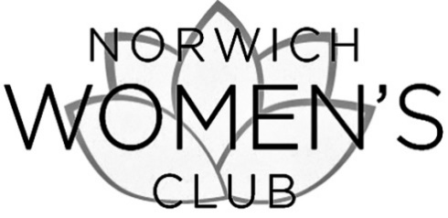

Annual Membership Dues (June 1, 2018 – May 31, 2019): $20.00

Please € initiate € renew my membership

COMPLETE THIS FORM & MAIL
WITH CHECK PAYABLE TO NORWICH WOMEN’S CLUB
TO: NWC, PO BOX 191, NORWICH, VT 05055

Name: ....................................................................................................................................

Address: .................................................................................................................................

Phone (home): ...................................................... (cell): .........................................................

Email: ....................................................................................................................................

I want to make an additional tax-deductible contribution to support the Norwich Women’s Club:

Contribution to Community Projects Fund $..................

Contribution to Scholarship Fund $..................

Dues payment $ 20.00
____________

TOTAL ENCLOSED $...................

Please make checks payable to the NORWICH WOMEN’S CLUB

This gift is given

€ in memory of .....................................................

€ in honor of .........................................................

€ I wish my gift to be anonymous

YOU CAN ALSO PAY ONLINE AT WWW.NORWICHWOMENSCLUB.ORG

